

UNIVERSITY OF KASHMIR

Main Campus Hazratbal, Srinagar,

Department of Computer Science.

SYNOPSIS FOR M.C.A PROJECT

|  |  |
| --- | --- |
| Project Title | Developing Cron Monitor |
| Submitted By | Ahtisham Shafi  Bisma Manzoor |
| University Supervisor | Dr. Javed Parvez  Dr. Arif Wani |
| Internship Supervisor | Er. Aamir Bhatt |

*Internship* outline

Our internship is divided into 3 phases and they are:

|  |  |
| --- | --- |
| Phase 1: | In first phase we learn the basics of technologies we are going to work with. |
| Phase 2: | In the next phase we write sample Programs in the technologies that we learned. |
| Phase 3: | In last phase we implement the  Knowledge by solving a real world problem. |

Developing Cron Monitor

*Introduction*

Cron is a system utility that can be used to schedule programs to run automatically at predetermined intervals. It is a Unix utility for automatic execution of task. For instance, you might have a script that produces web statistics that you want to run once a day automatically at some predefined time.

It is also know as cron job. Users that set up and maintain software environments use cron to schedule jobs to run periodically at fixed times,

dates, or intervals. It typically automates system maintenance or administration.

The actions of cron are driven by a crontab (cron table) file, a configuration file that specifies shell commands to run periodically on a given schedule.

*Problem*

Cron jobs or the processes that run regularly in the background are often not monitored and it becomes hard to track the status of their progress in a more coherent and manageable way.

By monitoring these crons on our servers will lead to more resource efficiency, better visibility of our application software and more pro activity of our IT infrastructure.

*Proposed System*

In this project we will build a web based cron monitoring and analysis system. The application will have two important parts, the client part which will run on the infrastructure server and the back-end part which will be a web based monitoring server presenting as a dashboard to users.

The client will monitor the cron jobs on the server and proactively send data points to the server.

The server will then present these data points in an understandable format and also log the history of crons run on a daily basis.

The communication between client and server will be JSON based. The client will also send notification emails to server administrators about the cron status.

*Technologies*

|  |  |
| --- | --- |
| Front-end | HTML,CSS,JavaScript/jQuery, Bootstrap |
| Back-end | Python, FastApi, MySQL |

Aamir Bhatt

Project Supervisor

Applied Informatics

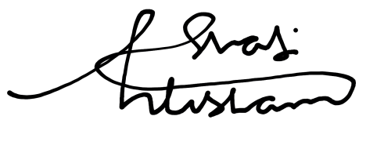

|  |  |
| --- | --- |
| Ahtisham Shafi | Bisma Manzoor |
| Intern | Intern |
| Applied Infromatics | Applied Informatics |